**Geographical Information Systems**

**Assignment 3**

Student Name: Mostafa Mohamed Mostafa Elgendy

Student ID: 20190543

Group No.: IS-S1

* **Specify your purpose of the assignment and how the selected layers will help you achieving it?**

1. **The Purpose of the Assignment is how to use Merge to Merge two or more Layers**
2. **Using Data analysis Techniques, To visualize very Important Information.**

**Layer Secall helps me to firstly Rename the 2 New Governments and Separate them into to different layers, therefore, dissolve them and the last step that is the assignment’s Purpose is that making merge between the 2 New Governments Dissolved with the Gov Layer.**

**And this also helps us in making analysis on the data of all Governments.**

1. **Copying all Layer of Secall**

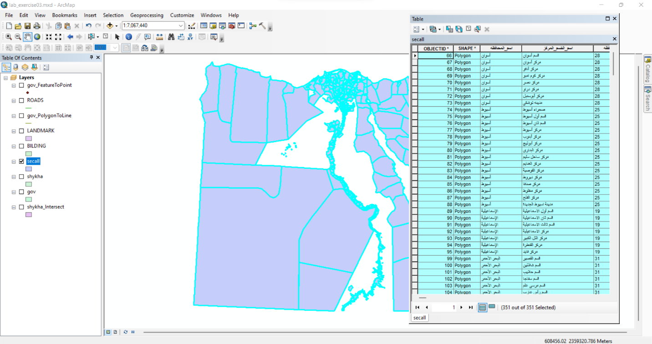

1. **Seeing New Layer**

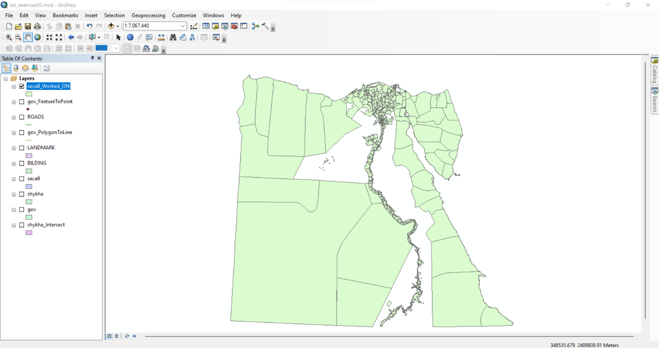

1. **Query For Selecting مراكز و اقسام of 6 October**

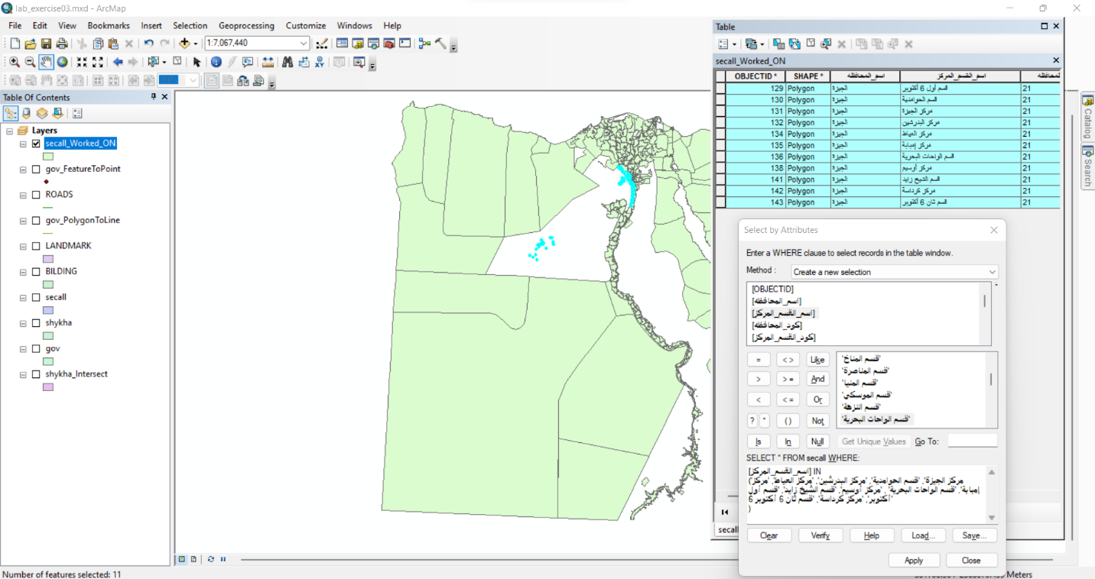

1. **Change to Gov Name to 6 اكتوبر and change كود المحافظة**

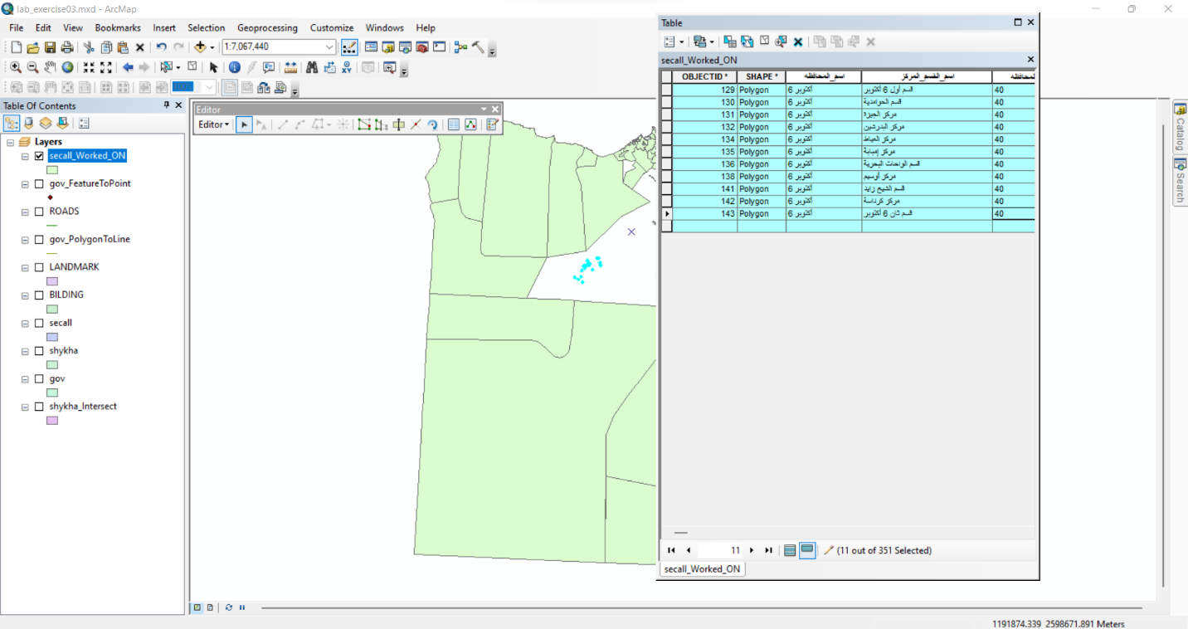

1. **Query For Selecting مراكز و اقسام of Helwan**

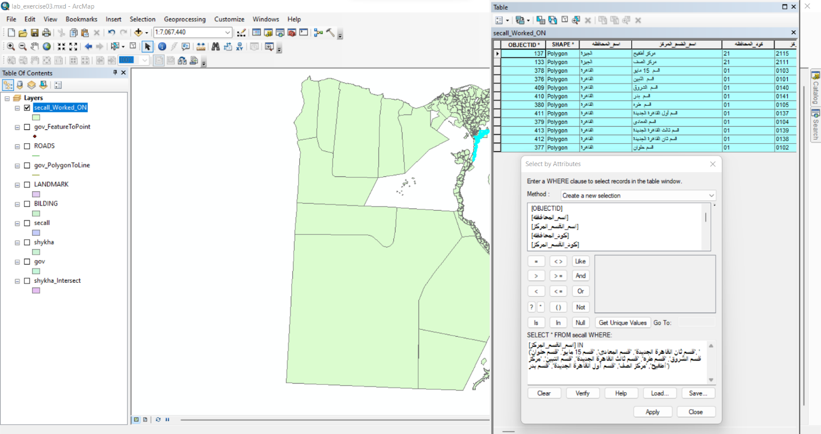

1. **Change to Gov Name to حلوان and change كود المحافظة**

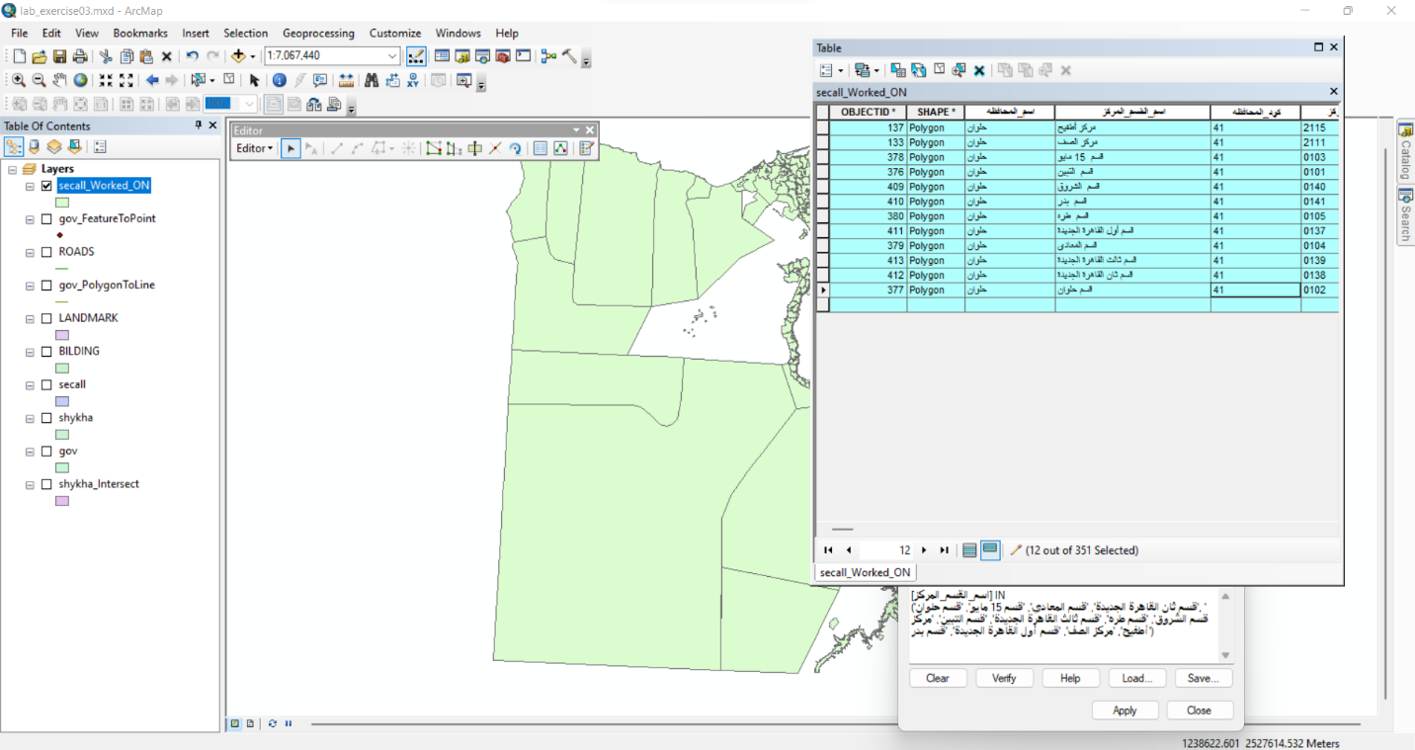

1. **Dissolve 6 October Layer**

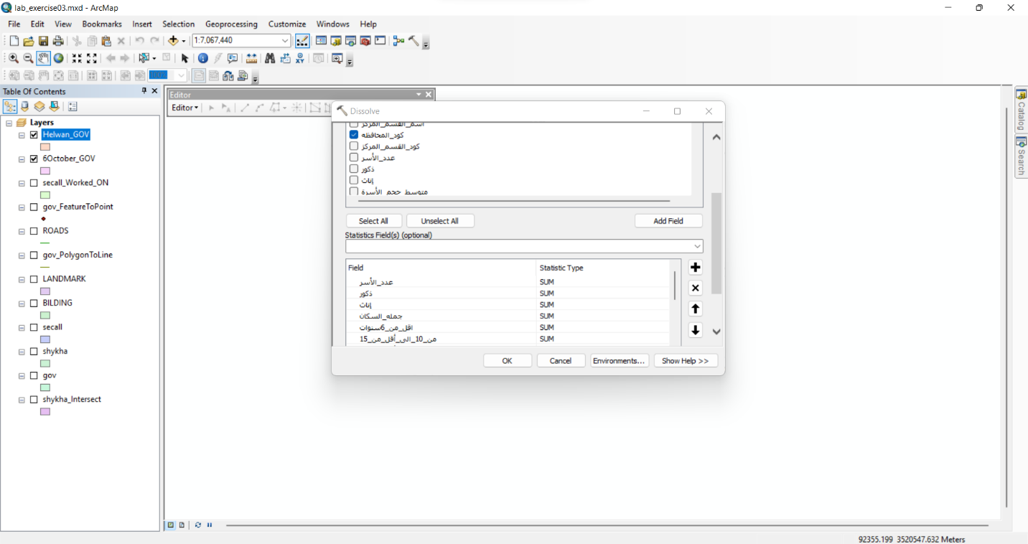

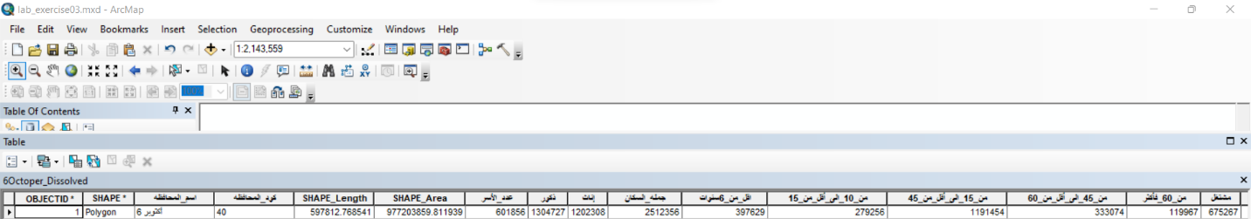

1. **Dissolve Helwan Layer**

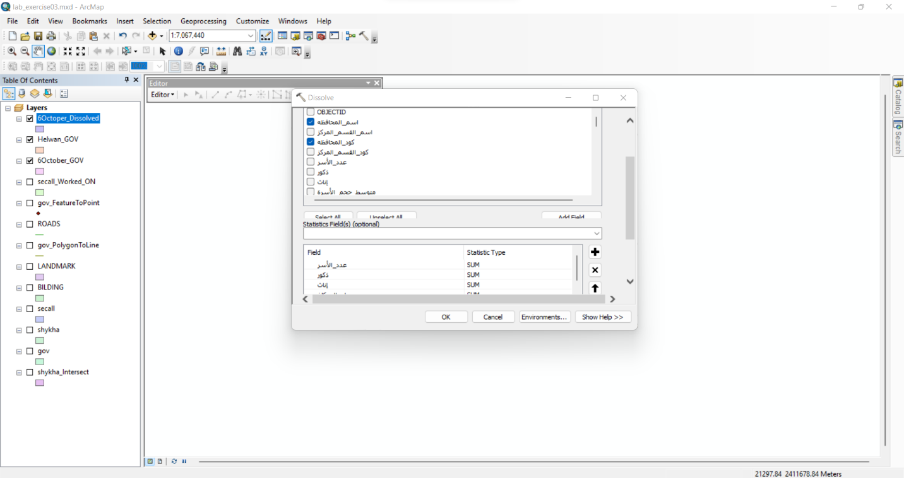



1. **After Merging the Gov, Helwan, 6 October**

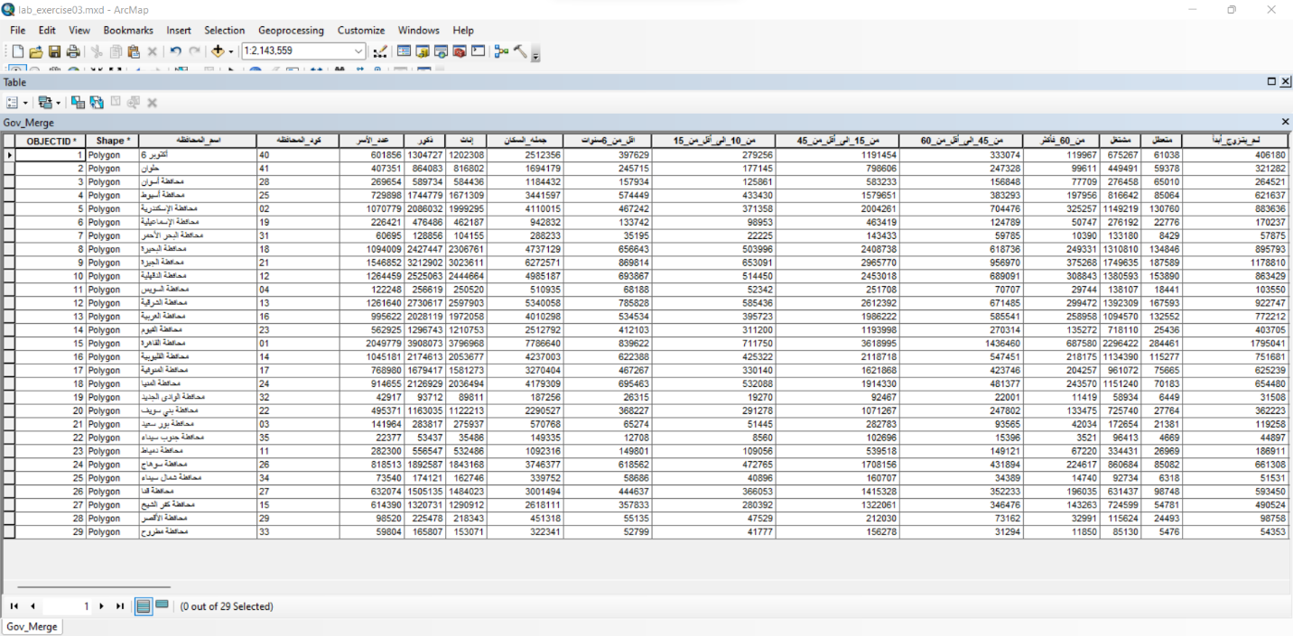

* **Create different types of all necessary graphs and reports**

1. **Report about Governments**

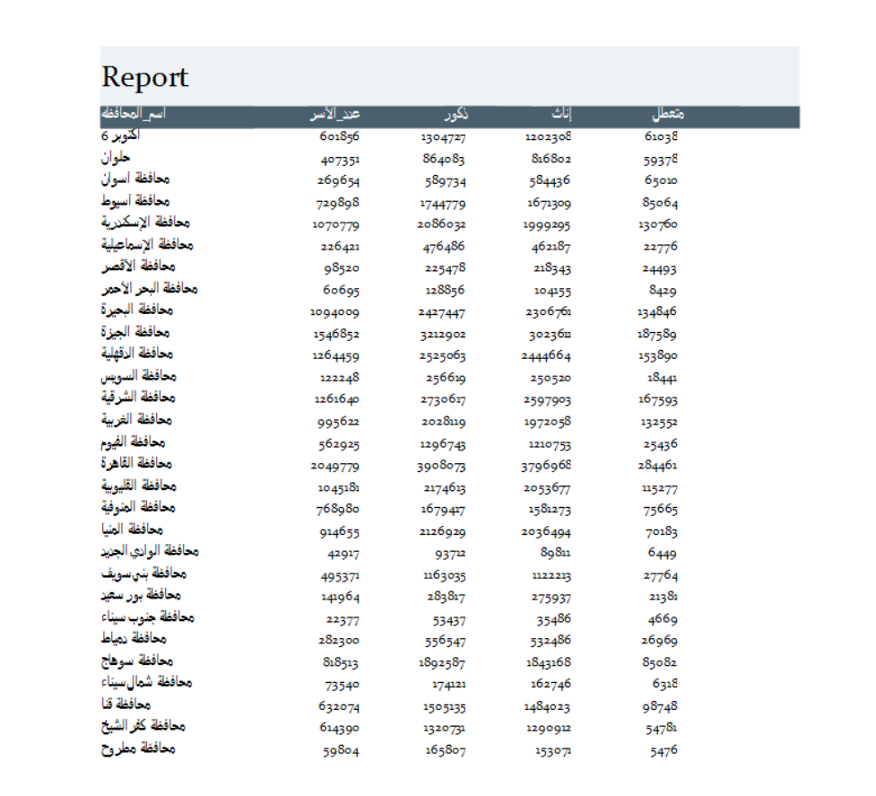

1. **Bar Chart Graph shows Family size Across Governments**

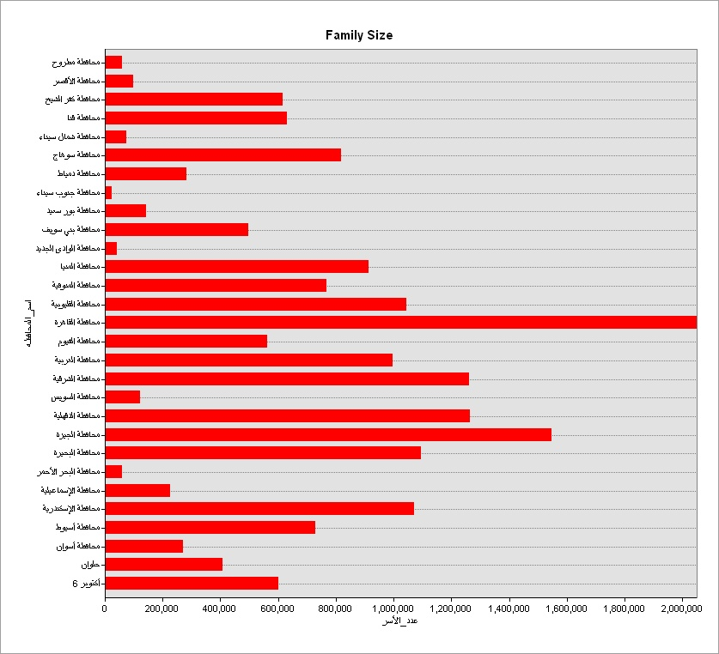

1. **Pie Chart for Unworkers across Governments**

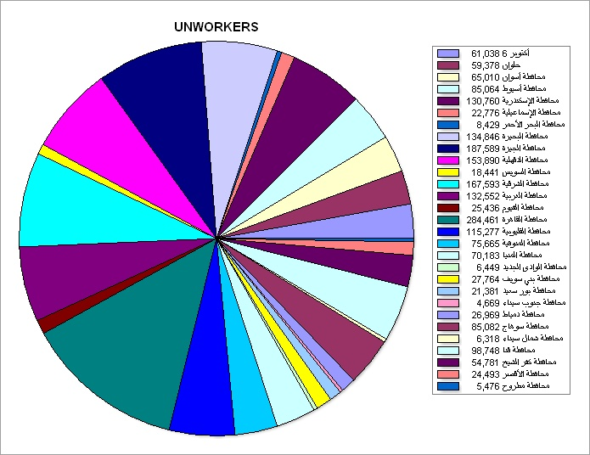

1. **Bar Chart for Married across Governments**

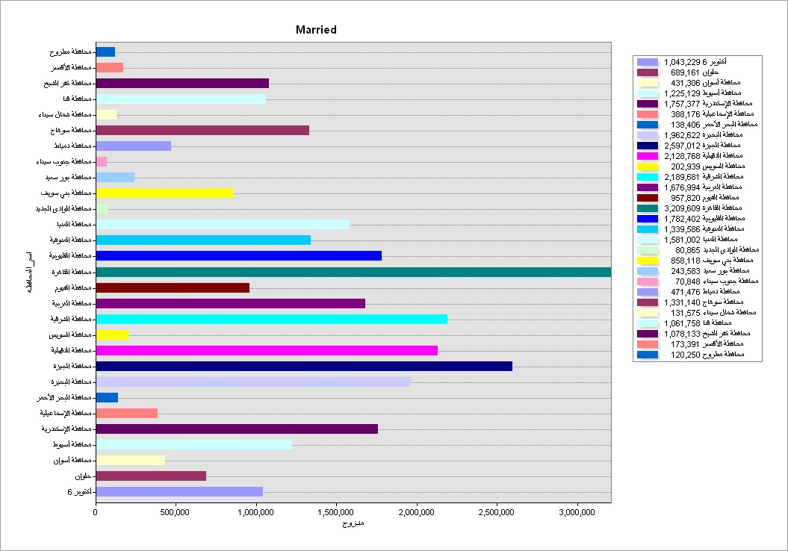

* **Map of Helwan Government**

